Birla Institute of Technology & Science - Pilani, Hyderabad Campus
Second Semester 2016-2017
CS F211: Data Structures & Algorithms
Test – 1
Date: 27.02.2017 Time: 60mins Type: Closed Book Marks: 60
-------------------------------------------------------------------------------------------------------------------------------
All parts of the same question should be answered together.
- a. Consider the following code fragment. [4 M]

for i=1 to n do
for j=i to 2*i do
output "foobar"

Let T(n) denote the number of times "foobar" is printed as a function of n. Find the asymptotic tighter upper bound of T(n).

b. Give the worst-case running time using Big Oh notation (asymptotic tighter upper bound) for the following function. [6 M]

function pesky(n)
r:=0
for i:=1 to n do
for j:=1 to i do
for k:=j to i+j do
r:=r+1
return(r)

c. Prove that any comparison sort must make Ω(n lg n) comparisons in the worst case to sort n elements [6 M]

- a. Two linked list of different lengths merge at a point. Two lists can merge as in the following figure where the lists merge at node containing 3 and thereafter contain same nodes:
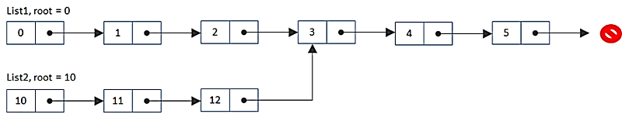

Devise a method that finds the node where the two lists merge without modifying any of the lists. You can only iterate over each list at most twice. Use O(1) extra memory. [8 M]

b. Fill up the incomplete parts of the function below marked by numbers from (1) to (5) to reverse the direction of a given singly-linked list. It returns the head of the reversed linked list. [10 M]

struct node  {  int data;  struct node *next;  }; | void reverselist(struct node **head)  {  struct node *prev = NULL, *curr = *head, *next;  while(curr) {  next = (1);  (2) = prev;  prev = (3);  (4);  }  (5);  }

c. You have n integers in the range [0 … k] where k < 10000. How would you process these integers into a data structure such that after preprocessing, the following query can be done in O(1) time: given two integers x and y, how many integers fall within the range [x,y]? [6 Marks]
- a Show that the running time of QUICKSORT is Ɵ(n²) when the array A contains distinct elements and is sorted in decreasing order. You need to write the recurrence to prove it. What is the running time of QUICKSORT when all the elements of array have the same value? [5 + 3 = 8M]

- Let merge (A;B) be the linear-time procedure that takes two sorted arrays, A and B, and returns a single sorted array that contains the elements A and B. Suppose you have k sorted arrays, each with n elements, and you want to combine them into a single sorted array.
- What is the time complexity (in terms of k and n) of the algorithm that merges the first two arrays to a bigger array, then merges the bigger array with the third array, then the fourth, and so on? [6 M]
ii. Give a more efficient algorithm having complexity of O(k n log k) to solve this problem.
[6 M]

************************** ALL THE BEST *******************************

